Mark your calendars — Tuesday, August 2nd is
International Golden Lion Tamarin Day!
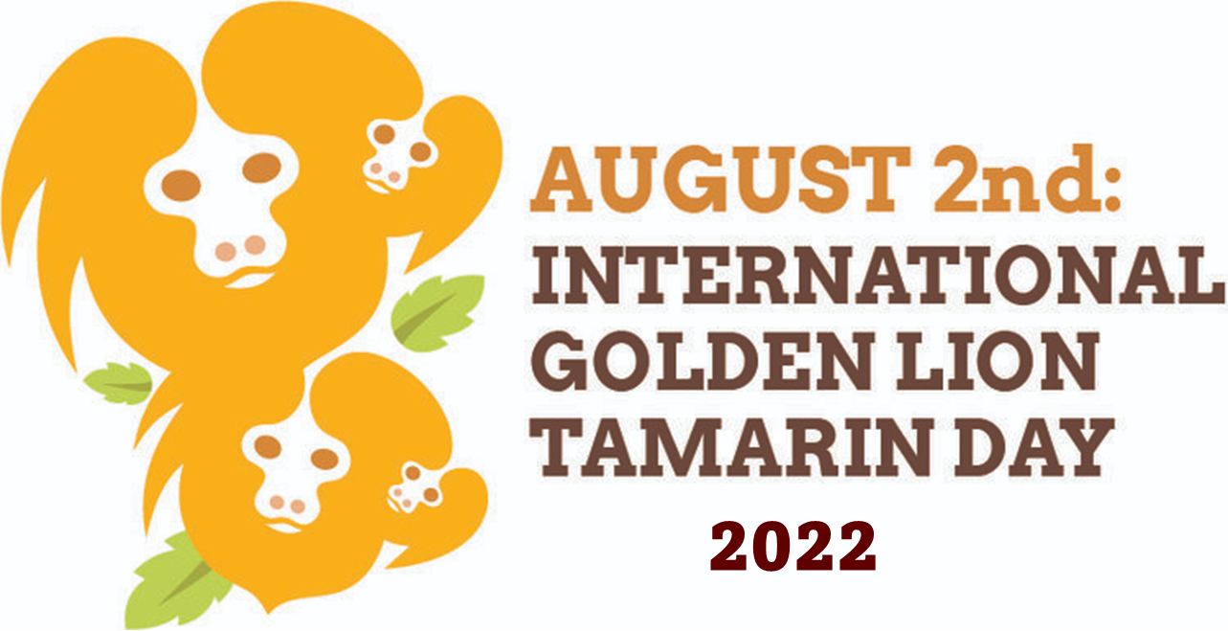
We hope your zoo will join Save the Golden Lion Tamarin (SGLT) and Associação Mico-Leão-Dourado (AMLD) to celebrate golden lion tamarins (GLTs) on Tuesday, August 2nd, 2022.
GLTs are small monkeys native to the lowland Atlantic Coastal Rainforest of southeastern Brazil. In the 1970s, 43 zoos and breeding facilities stepped in to help save these critically endangered animals through a comprehensive breeding program, which resulted in the reintroduction of 146 zoo-born GLTs back into their native habitat in Brazil between 1984 and 2000. Today, over 70% of the current wild GLT population descends from those reintroduced individuals. The wild population has recovered thanks to significant conservation efforts in Brazil and from supporting zoos around the world. In 2003 GLTs were “uplisted” from critically endangered to endangered. Today the wild GLT population is estimated at 2,600 individuals, and 156 zoos around the world collaborate in maintaining an insurance population should a disaster occur in the wild.
Despite these successes, the survival of these endangered animals is a continuing effort due to the fragmentation of their remaining habitat in Brazil and new threats, such as a yellow fever outbreak, that have arisen. On GLT Day, SGLT and AMLD will share updates of how global partners are working together to build forest corridors, planting trees, vaccinating the wild GLT population, and conducting activities to ensure GLTs’ wellness. This year, AMLD is celebrating its 30 years of conservation work.
This GLT Day, there are opportunities for tamarin fans worldwide to join the celebration.
Photo Challenge - SGLT is sponsoring a golden lion tamarin photo challenge. This year we are saluting the important role zoos and aquariums have in GLT conservation by inviting photographers in three categories – professional, nonprofessional, and zoo staff – to submit a zoo-based photo of this beautiful endangered Brazilian monkey.
The winners in each category will be announced on GLT Day and will have a tree planted in their honor. The deadline for submissions is July 25, 2022. Click here to read full details on this challenge and to find out how to enter.
Additionally, SGLT and AMLD invite everyone to visit the GLT Day webpage for GLT-themed crafts and activities. Be sure to follow us on Facebook, Twitter, and Instagram to stay updated on GLT news and activities.
Suggested zoo social media posts - Help spread the word about GLT Day and the importance of this animal that lives in one of the most threatened and biologically diverse areas on the planet.
Please tag @SaveGLTs and @associacaomicoleaodourado and use these hashtags #SomosTodosMicoLeaoDourado #sglt #gltday #Biodiversity #AtlanticForest #Zoos and #PartnersInConservation.

(Suggested dates for postings are flexible based on best judgment.)

Additionally, zoo and aquarium partners can find activities, fact sheets and photos of GLT conservation available for download for use in GLT exhibits and with your zoo public at the GLT Day webpage.

Twitter

(Before July 25) - Show us your pics! #Photographers of all ages are encouraged to participate in the Golden Lion Tamarin Day (Aug. 2) photo challenge. Deadline July 25. (Website -https://www.savetheliontamarin.org/2022gltdaychallenge)

July 10 - Golden Lion Tamarin Day is Aug. 2! Help us celebrate with #Zoos and their #WildlifeConservationists worldwide in their work to save this animal from extinction. (Website - https://www.savetheliontamarin.org/annual-glt-day)

July 20 - Everyone’s invited! On Aug. 2, the world will celebrate Golden Lion Tamarin Day. See what is planned to celebrate #Zoo and #WildlifeConservation partnerships. (Website - https://www.savetheliontamarin.org/annual-glt-day)

July 25 - Today is the last day for submission for the #PhotoChallenge of GLTs in #zoos. See guidelines here: https://www.savetheliontamarin.org/2022gltdaychallenge

July 30 - Did You Know? (DYK): In the 1970s, #Zoos began helping save #CriticallyEndangered Golden Lion Tamarins, which led to the reintroduction of zoo-born GLTs back into their native habitat in Brazil. #GLTDay is Aug. 2. (Website - https://www.savetheliontamarin.org/annual-glt-day)

Aug. 1 - Are you ready to celebrate GLTs? See what we have planned for Golden Lion Tamarin Day tomorrow – Aug. 2 – by visiting the GLT Day webpage. (Website - https://www.savetheliontamarin.org/annual-glt-day)

Aug. 2 - It’s Golden Lion Tamarin Day! Join us as we celebrate this tiny but mighty monkey and the global partners (including #Zoos) that are working together to protect its survival. (Website - https://www.savetheliontamarin.org/annual-glt-day)

Aug. 3 – Thank you so much for celebrating Golden Lion Tamarin Day with us on Aug. 2! Visit our website for winners of our #PhotoChallenge.
(Website - https://www.savetheliontamarin.org/annual-glt-day)

Facebook

(Before July 24) - Calling all animal-loving photographers! International Golden Lion Tamarin Day is coming up on Tuesday, August 2, and we want you to join us in celebrating. Photographers of all ages — professional, nonprofessional and zoo staff – are invited to create a tribute to GLTs, celebrating the conservation of these endangered monkeys. Winners will be selected on GLT Day and will have a tree planted in the Atlantic forest in Brazil in their honor. The deadline for submissions is July 25.
Visit the link below to find out more about the GLT #PhotoChallenge and how you can get involved in this year’s GLT Day festivities!
https://www.savetheliontamarin.org/2022gltdaychallenge

July 12 -- DYK: Golden lion tamarins use their long tails for balance as they leap from branch to branch in the trees? Learn more facts about these endangered monkeys from the Atlantic Coastal Rainforest of southeastern Brazil during this year’s Golden Lion Tamarin Day on Tuesday, Aug. 2.
Visit the link below to find out more about this year’s GLT Day festivities!
https://www.savetheliontamarin.org/annual-glt-day

July 19 -- Your support for zoos benefits animals here, in zoos across the world, and even animals living in the wild. In the 1970s, the golden lion tamarin population in Brazil dipped to around 200, and the species was declared critically endangered. Global partnerships with #Zoos and wildlife conservationists helped increase the population and reintroduce more monkeys into the wild. In the early 2000s, the status of GLTs was upgraded to endangered because of these efforts. Help us celebrate this history — and the work ahead — on Tuesday, Aug. 2 as we mark Golden Lion Tamarin Day.
Visit the link below to find out more about this year’s GLT Day festivities!
https://www.savetheliontamarin.org/annual-glt-day

July 28 -- You’re invited! On Tuesday, Aug. 2 this year, people across the globe will celebrate Golden Lion Tamarin Day. On this day, we take time to celebrate this special species and the efforts being made to prevent its extinction. Join us and our global partners as we share details of this important work and raise awareness around this continued mission.
Visit the link below to find out more about this year’s GLT Day festivities!
https://www.savetheliontamarin.org/annual-glt-day

Aug. 1 -- What’s small, reddish-gold, and one of the most threatened primates in the world? Answer: Golden Lion Tamarins. Join our worldwide partners tomorrow, Tuesday, Aug. 2 as we mark Golden Lion Tamarin Day and raise awareness about the work being done to save this animal from extinction. Visit the link below to find out more about this year’s GLT Day festivities!
https://www.savetheliontamarin.org/annual-glt-day

Aug. 2 -- Today is Golden Lion Tamarin Day! Join us and our friends at Save the Golden Lion Tamarins and at Associação Mico-Leão-Dourado as we honor this special species and the efforts of many others around the world — including at #zoos — to ensure this animal’s survival in the wild. Visit the link below to find out more about this year’s GLT Day festivities!
https://www.savetheliontamarin.org/annual-glt-day

Aug 3 -- Thank you so much for celebrating Golden Lion Tamarin Day with us and our global wildlife conservation partners from all across the world! To learn about the continuing effort to protect this special species, visit our Save the Golden Lion Tamarin friends at https://www.savetheliontamarin.org/

Happy Golden Lion Tamarin Day!

Lou Ann Dietz, President
Save the Golden Lion Tamarin
303 Cavalier Ct – Silver Spring, MD 20901 USA
contact@savetheliontamarin.org | facebook.com/saveGLTs
Twitter: @SavetheGLT | Instagram: Save_the_GLT
Join our newsletter!

Save the Golden Lion Tamarin is a United States 501 (c) (3) public charity, created in 2005 by a small group of passionate U.S.-based conservation professionals who have dedicated their careers to golden lion tamarin conservation. Save the Golden Lion Tamarin provides technical and financial support to our Brazilian partner non-profit Associação Mico-Leão-Dourado (AMLD - Golden Lion Tamarin Association) toward achieving our joint mission: keeping golden lion tamarins safe from extinction in their native Atlantic Forest in Rio de Janeiro, Brazil.

