PRESS RELEASE
November 20, 2020
FOR IMMEDIATE RELEASE

Yellow Fever Vaccination of Wild Golden Lion Tamarins Aims to Save the Species
Endangered Golden Lion Tamarin monkeys (GLTs), rescued from the brink of extinction by decades of collaborative efforts initiated in the 1970’s, have become a flagship species and a symbol for conservation of the environment in Brazil. Today, that progress is at risk. Thirty-two percent of Brazil’s GLTs died during an outbreak of yellow fever that began in 2017 in the only region where the species occurs, remnants of lowland Atlantic Forest in the state of Rio de Janeiro. Numbers fell from about 3,700 to 2,500 (https://www.nature.com/articles/s41598-019-49199-6). The yellow fever virus is transmitted by mosquitos and impacts both people and non-human primates. Whereas the majority of people in the area of the outbreak were vaccinated for the disease in a campaign led by Brazilian health authorities, until recently no vaccine existed to protect GLTs.
Brazil’s Associação Mico-Leão-Dourado (AMLD) in partnership with the Oswaldo Cruz Foundation, Northern Fluminense State University (UENF), the Rio de Janeiro Primatology Center (CPRJ/INEA), and Save the Golden Lion Tamarin (a U.S. public charity) is coordinating an unprecedented campaign to vaccinate GLTs against yellow fever in the wild. Dr. Marcos da Silva Freire, a Brazilian virologist and AMLD board member, led studies to adapt a human yellow fever vaccine produced by the Oswaldo Cruz Foundation for use in non-human New World primates. The immunizing agent was tested first in GLTs captive at CPRJ. Following positive results of immunization and safety in captive GLTs, vaccination of wild GLTs began on October 08, 2020. To date, AMLD’s field team has vaccinated 57 GLTs for yellow fever.
Vaccinations began with GLT groups monitored by AMLD field team, some since the 1980s. GLT family groups are captured safely in the forest, taken to AMLD’s headquarters, vaccinated and observed for 24 hours before they are returned to the forest where they are monitored intensively. Biologist Andréia Martins, AMLD field team coordinator, reports that all vaccinated GLTs are doing fine in the forest. Some of the immunized groups will soon be moved to the Poço das Antas Biological Reserve and other forest fragments where GLT populations were decimated by yellow fever. Free from threat of this disease, vaccinated groups can safely repopulate those areas.
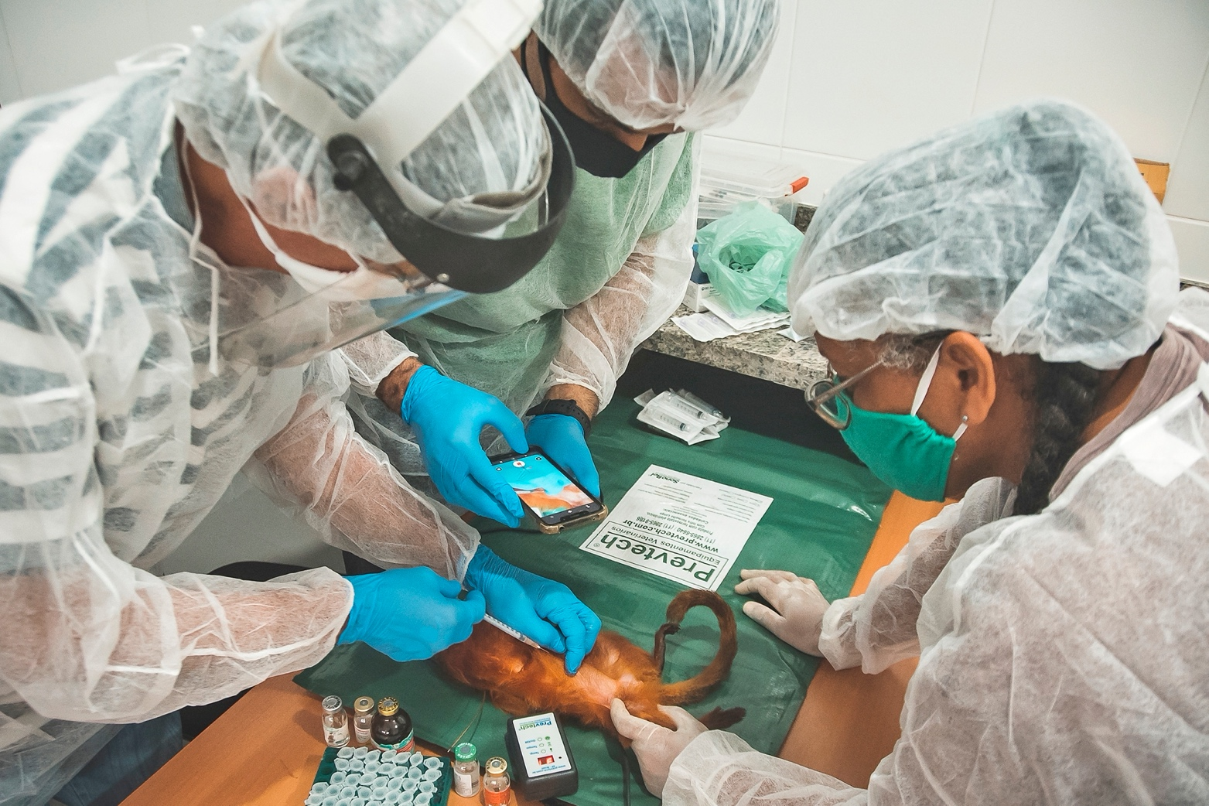
Caption: First yellow fever vaccination of wild Golden Lion Tamarins - 8 October 2020
Left to right: Dr. Marcos da Silva Freire (Oswaldo Cruz Foundation virologist); Flavio Soffiati (veterinarian), and Andréia Martins (AMLD biologist and field team coordinator)
Photo Credit: Luiz Thiago de Jesus /Associação Mico-Leão-Dourado

Caption: Dr. Marcos da Silva Freire (Oswaldo Cruz Foundation virologist) prepares a yellow fever vaccination for wild Golden Lion Tamarins - 8 October 2020
Photo Credit: Luiz Thiago de Jesus /Associação Mico-Leão-Dourado
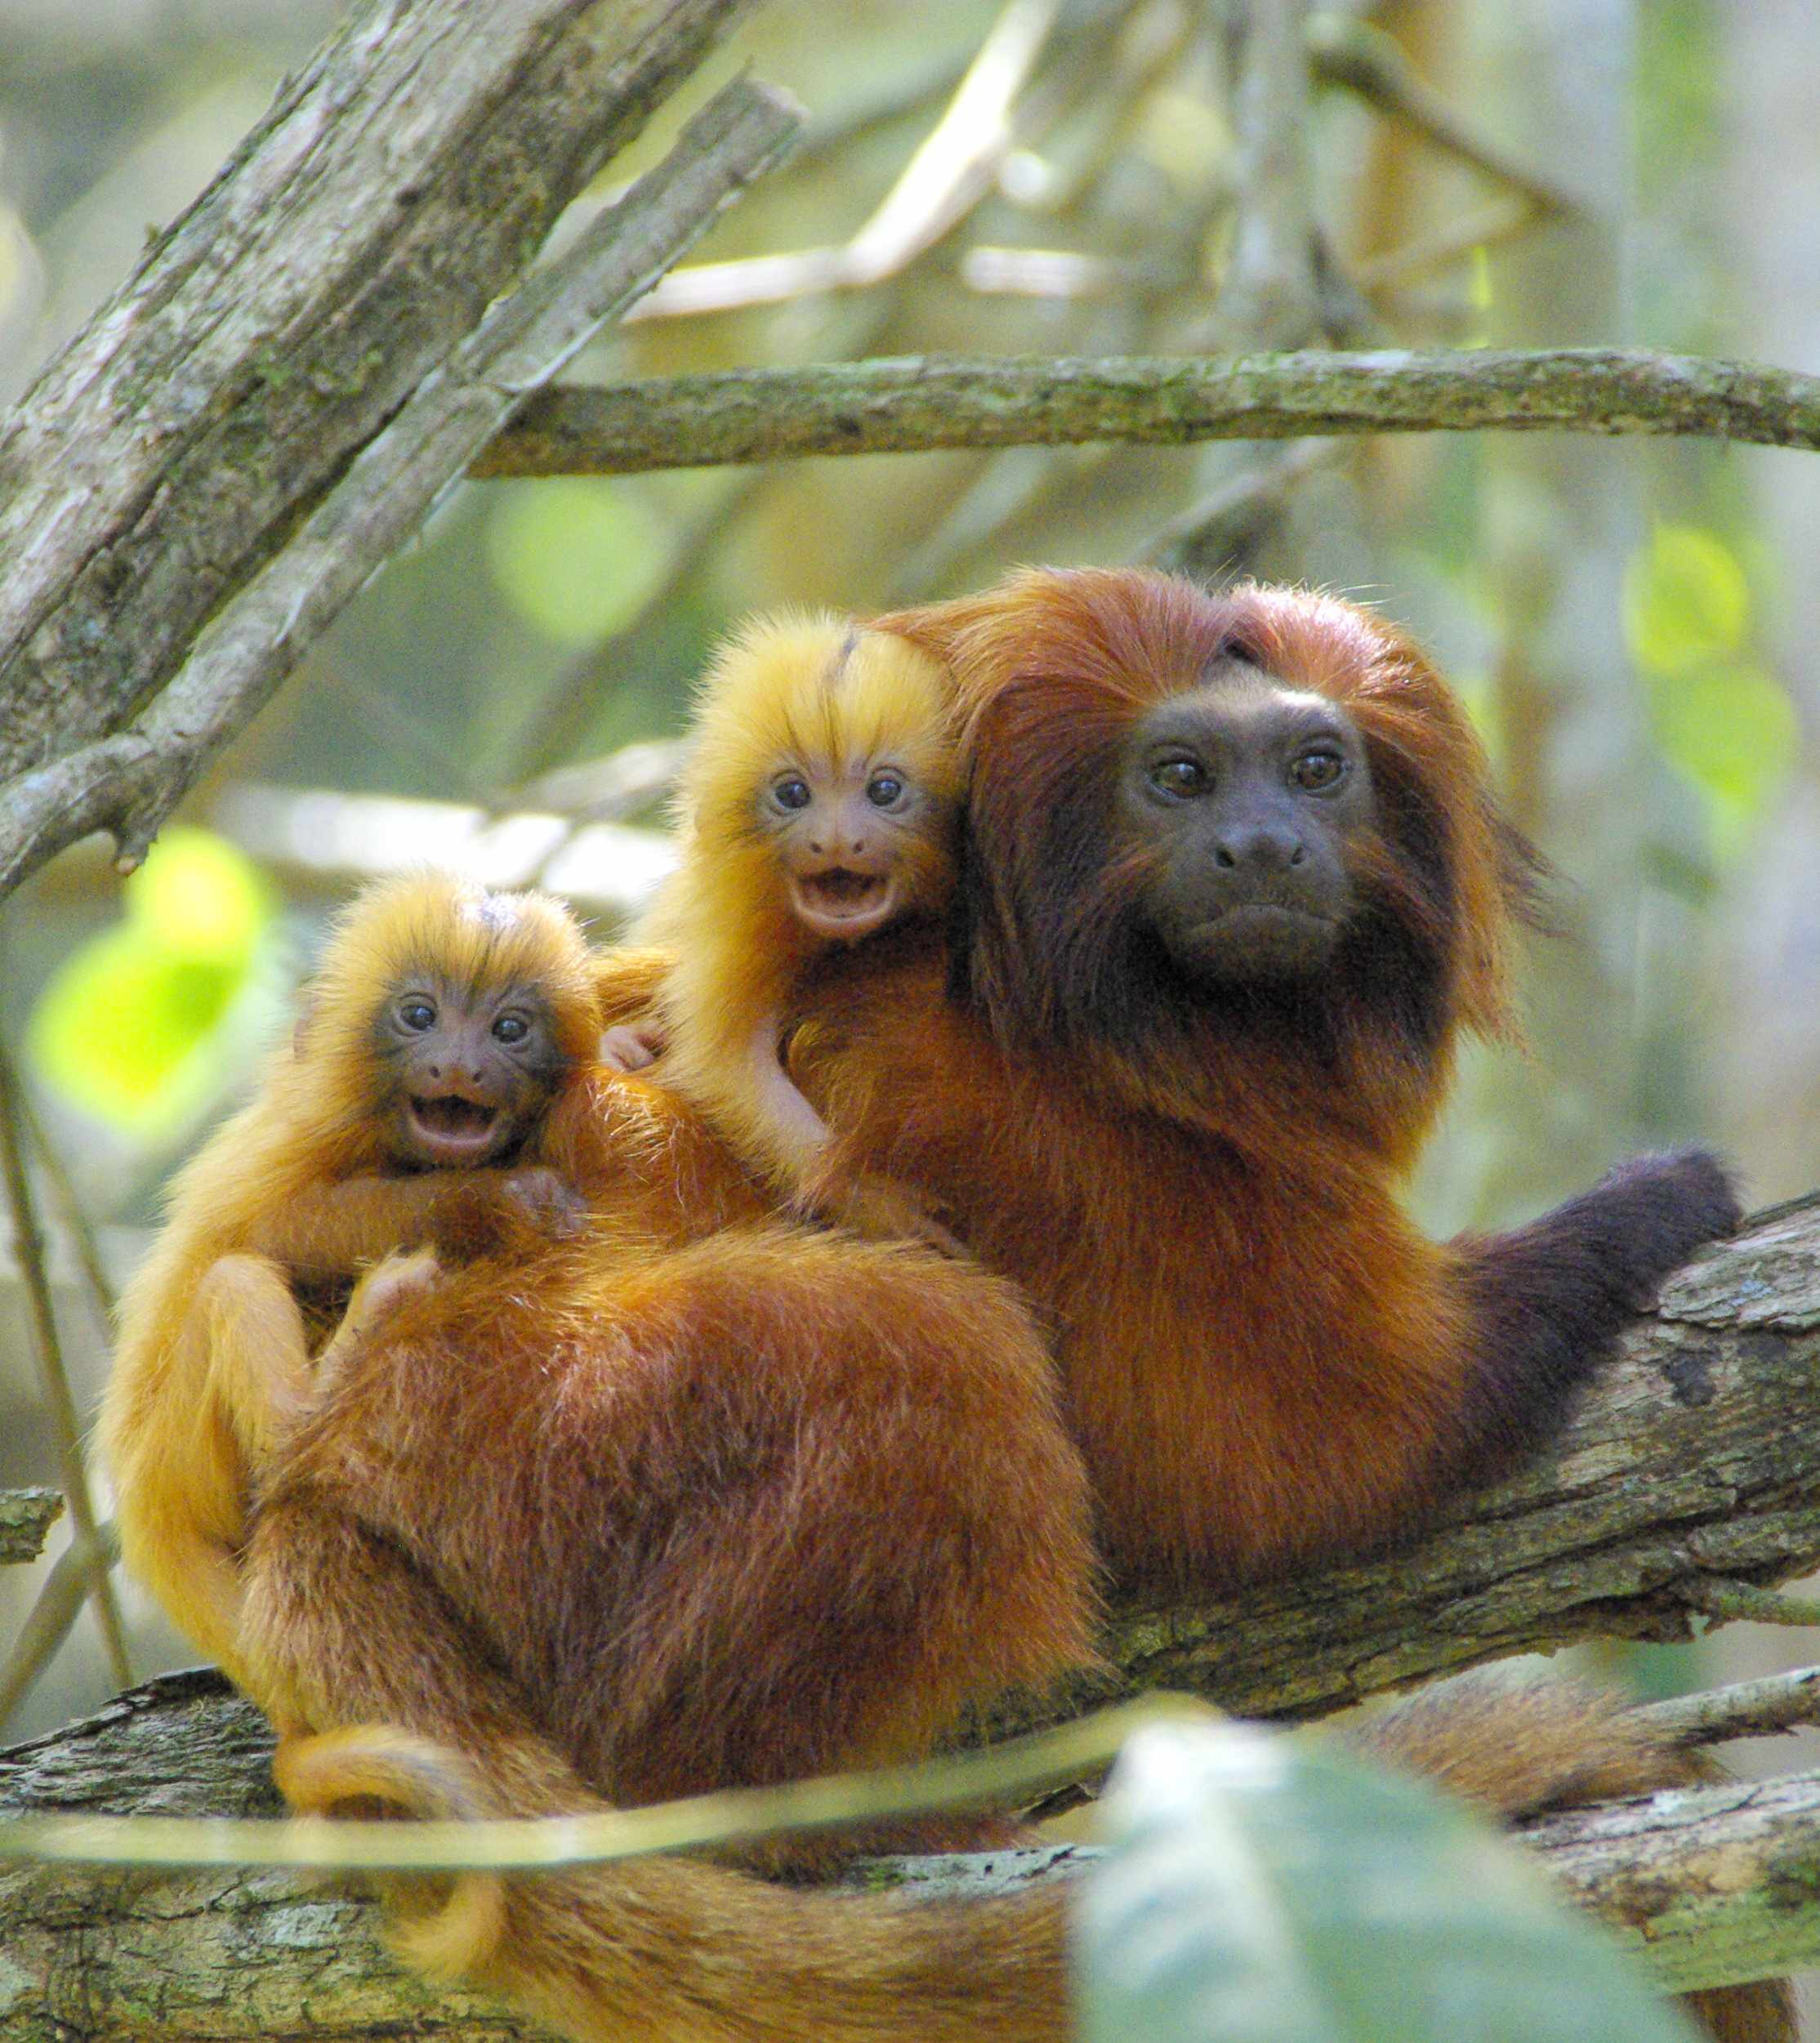
Caption: Wild Golden Lion Tamarin mother and twins
Photo Credit: Andréia Martins /Associação Mico-Leão-Dourado

####
Associação Mico-Leão-Dourado
Associação Mico-Leão-Dourado (AMLD) is a Brazilian nonprofit established in 1992 that is responsible for coordinating all efforts to save Golden Lion Tamarins in their native forest and protect the benefits that the forest provides to local people. AMLD works on the ground in Rio de Janeiro to monitor GLTs and forests, advocate for restoration of the Atlantic Forest, plant forest corridors, and engage local people in protecting their forest. www.micoleao.org.br
Save the Golden Lion Tamarin
Save the Golden Lion Tamarin (SGLT) is a U.S.-based public charity that provides technical and financial support to help Associação Mico-Leão-Dourado achieve our shared vision of saving GLTs and the habitat they depend upon for survival www.SavetheLionTamarin.org
Contact
Save the Golden Lion Tamarin
contact@savetheliontamarin.org ﻿

