4 August 2016
MEDIA RELEASE by SAVE THE GOLDEN LION TAMARIN
(contact@savetheliontamarin.org)
GLTs Carry the Olympic Torch on its way to Rio's 2016 Olympic Games
On its way to the city of Rio to open the Olympic Games, the Olympic flame traveled through coastal Rio de Janeiro state, the region containing the last remaining fragments of Golden Lion Tamarin (GLT) habitat! On Tuesday, August 2 at 11:30AM Rio time, Andreia Martins, Associação Mico-Leão-Dourado biologist, carried the Olympic Torch in the town of Rio Bonito https://www.rio2016.com/en/torchbearers-schedule-rio-bonito-rj-2016-08-02. Together with the Olympic Flame, she carried more than 30 years of experience with golden lion tamarins representing all of us who share in the work of assuring a future for the species in the wild!
Andreia was selected as an Olympic Torch bearer because she is making a difference in her community. Coordinator of the Associação Mico-Leão-Dourado GLT Monitoring Team, Andreia has worked in these forests since she was 19 years old, bringing the species back from the brink of extinction by successfully reintroducing zoo-born GLTs to their native forest home. With the support of partners in Brazil and around the world, the Associação Mico-Leão-Dourado continues to watch over the GLTs and restore and protect enough forest for the species to continue to have a home in Rio de Janeiro into the future.

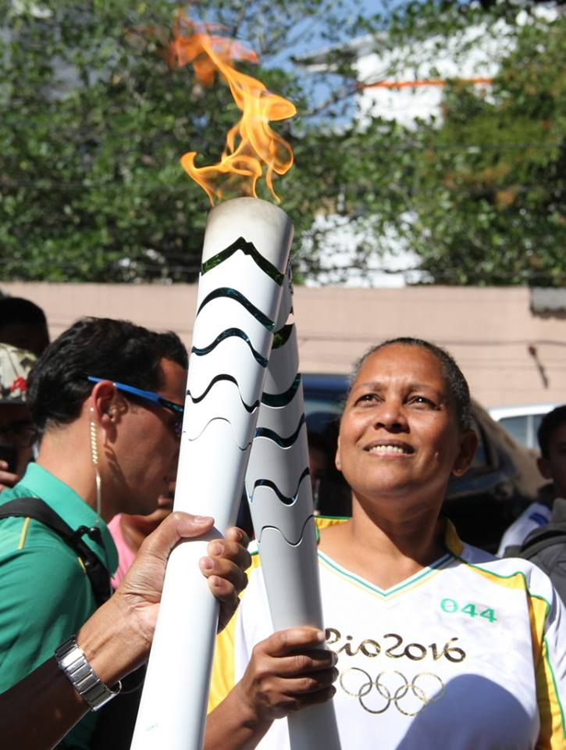
Andreia Martins, Associação Mico-Leão-Dourado biologist, carries the Olympic Torch on August 2nd.
Photo Credit: Associação Mico-Leão-Dourado

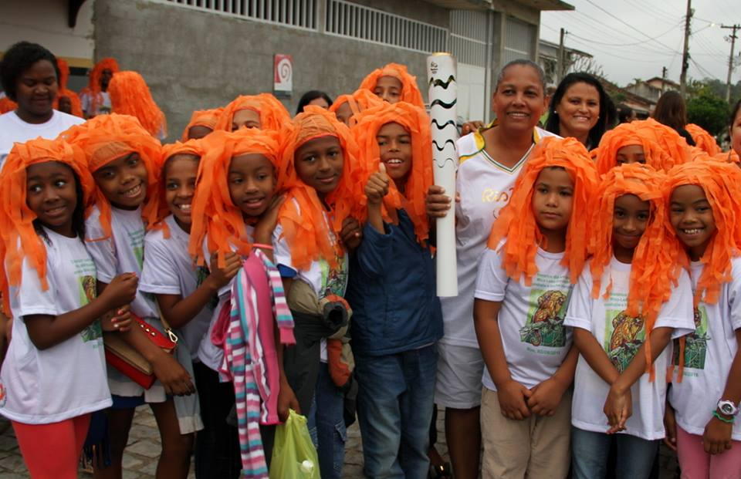
Students with GLT "manes" pose with Andreia Martins, Associação Mico-Leão-Dourado biologist and Olympic Torch bearer, at the celebration August 3rd.
Photo Credit: Associação Mico-Leão-Dourado
On August 3, the celebration continued. Andreia’s home town of Silva Jardim, Rio de Janeiro, commemorated “The Historic Day the Golden Lion Tamarin Carried the Olympic Torch”. AMLD’s Facebook events tab https://www.facebook.com/events/635311433295482/?active_tab=posts covered the event in English and in Portuguese.
9:00 AM (Rio time) | Andreia led a parade with the Torch (the flame has gone on to open the games in the city of Rio on August 5), accompanied by 500 local school children wearing GLT wigs and T-shirts purchased by local sponsors.
9:45 AM | Parade arrived at the town square for: music; presentations by a local musical theater group; and announcement of the winners of the Golden Lion Tamarin Drawing, Essay, Poem, and Music Contests.
11:00 AM | Delivery of the Torch to the local Cultural Center where it will remain on display during the entire Rio 2016 Olympic Games.

For more information:

Associação Mico-Leão-Dourado
www.micoleao.org.br
Facebook associacaomicoleaodourado

Save the Golden Lion Tamarin
www.savetheliontamarin.org
Facebook saveglts
Twitter @SaveTheGLT

Official Rio2016 Olympics site: https://www.rio2016.com/en/news/fighting-for-diversity-three-pioneers-in-their-field-to-run-with-olympic-torch-in-rio-de-janeiro

